[Organisation]
Organization Model for Enterprise Architecture
What the architecture capability is, what it is scoped to cover, and what constrains it
Field | Detail
Document | Organization Model for Enterprise Architecture
Version | 0.1 — Draft, not yet ratified
Date | March 2027
Owner | Chief Enterprise Architect
Approver | Architecture Board, endorsed by Group Executive Committee
Status | Draft. Ratified alongside the Architecture Governance Framework.
Relationship | Companion to the EA Operating Model. That describes how the capability works; this describes what it is.
Classification | Internal

Contents
1. Purpose and scope
2. Scope of organisations impacted
3. Structure of the architecture function
4. Roles and responsibilities
5. Federated architecture capacity
6. Skills against requirement
7. Maturity, gaps and resolution
8. Constraints
9. Sizing and budget
10. Governance and support strategy
11. Document control

1. Purpose and scope
This is the Organization Model for Enterprise Architecture required by the Preliminary Phase. It describes the architecture capability itself: what it is scoped to cover, how it is structured, who does what, what skills it requires against what it holds, where architecture sits outside the central function, and what constrains it.
It is a companion to the EA Operating Model and deliberately separate from it. That document describes how the capability works — its two operating models, gates, forms and escalation. This one describes what the capability is.

The single fact that shapes everything here
Fourteen positions, of which two are vacant and one interim, against an establishment of 4,805 people and five lines of business. Every design decision in this document follows from that ratio, and a model that assumed a full establishment would be describing a different organisation.

2. Scope of organisations impacted
Four categories, following the TOGAF classification. Core organisations are bound by the architecture and change as a result of it. Soft organisations are affected but their own work does not change. Extended organisations sit outside the enterprise but are required for the architecture to work. Communities shape it without being party to it.
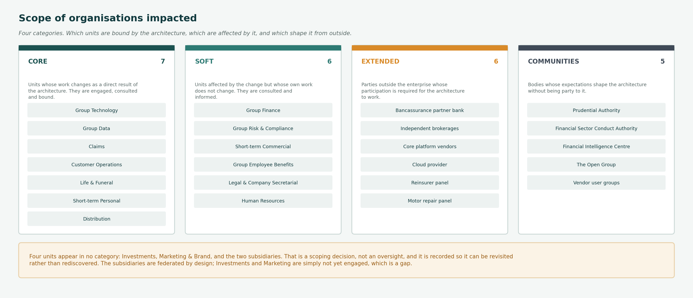
Figure 1 — Scope of organisations impacted, by category.
Core — 7 organisations
Units whose work changes as a direct result of the architecture. They are engaged, consulted and bound.
Group Technology · Group Data · Claims · Customer Operations · Life & Funeral · Short-term Personal · Distribution
Soft — 6 organisations
Units affected by the change but whose own work does not change. They are consulted and informed.
Group Finance · Group Risk & Compliance · Short-term Commercial · Group Employee Benefits · Legal & Company Secretarial · Human Resources
Extended — 6 organisations
Parties outside the enterprise whose participation is required for the architecture to work.
Bancassurance partner bank · Independent brokerages · Core platform vendors · Cloud provider · Reinsurer panel · Motor repair panel
Communities — 5 organisations
Bodies whose expectations shape the architecture without being party to it.
Prudential Authority · Financial Sector Conduct Authority · Financial Intelligence Centre · The Open Group · Vendor user groups

Four units are in no category
Four units appear in no category: Investments, Marketing & Brand, and the two subsidiaries. That is a scoping decision, not an oversight, and it is recorded so it can be revisited rather than rediscovered. The subsidiaries are federated by design; Investments and Marketing are simply not yet engaged, which is a gap.

3. Structure of the architecture function
Fourteen positions in three layers, reporting to the Chief Enterprise Architect. The organogram below shows the establishment as it stands, including the two vacancies and the interim appointment.
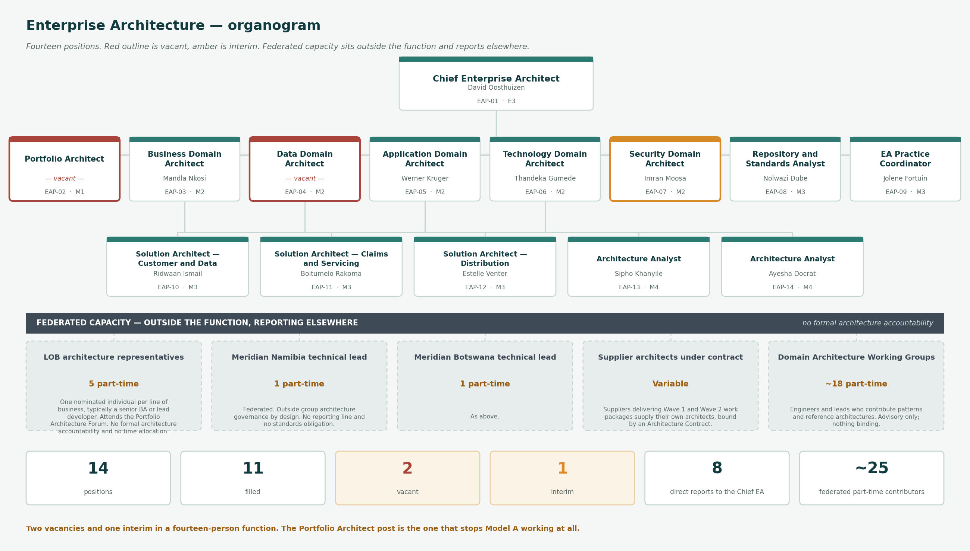
Figure 2 — The enterprise architecture organogram, with federated capacity shown beneath.

3.1 Establishment
Position | Title | Incumbent | Reports to | Grade | Status | FTE
EAP-01 | Chief Enterprise Architect | David Oosthuizen | Chief Information Officer | E3 | Filled | 1
EAP-02 | Portfolio Architect | — vacant — | EAP-01 | M1 | Vacant | 1
EAP-03 | Business Domain Architect | Mandla Nkosi | EAP-01 | M2 | Filled | 1
EAP-04 | Data Domain Architect | — vacant — | EAP-01 | M2 | Vacant | 1
EAP-05 | Application Domain Architect | Werner Kruger | EAP-01 | M2 | Filled | 1
EAP-06 | Technology Domain Architect | Thandeka Gumede | EAP-01 | M2 | Filled | 1
EAP-07 | Security Domain Architect | Imran Moosa | EAP-01 | M2 | Interim | 1
EAP-08 | Repository and Standards Analyst | Nolwazi Dube | EAP-01 | M3 | Filled | 1
EAP-09 | EA Practice Coordinator | Jolene Fortuin | EAP-01 | M3 | Filled | 1
EAP-10 | Solution Architect — Customer and Data | Ridwaan Ismail | EAP-04 | M3 | Filled | 1
EAP-11 | Solution Architect — Claims and Servicing | Boitumelo Rakoma | EAP-05 | M3 | Filled | 1
EAP-12 | Solution Architect — Distribution | Estelle Venter | EAP-05 | M3 | Filled | 1
EAP-13 | Architecture Analyst | Sipho Khanyile | EAP-03 | M4 | Filled | 1
EAP-14 | Architecture Analyst | Ayesha Docrat | EAP-06 | M4 | Filled | 1

Eight direct reports to the Chief Enterprise Architect
Wide for a fourteen-person function, and a consequence of having no deputy. The Portfolio Architect post, once filled, takes Model A and its forum, which is the practical remedy. Until then Model A runs on the Chief Enterprise Architect's residual time and the roadmap does not reach a planning cycle.

4. Roles and responsibilities
What each position is for. Responsibilities within the two operating models are set out in the EA Operating Model; this states the standing accountability.

Position | Title | Focus
EAP-01 | Chief Enterprise Architect | Owns the capability, chairs the Architecture Board, signs Architecture Contracts.
EAP-02 | Portfolio Architect | Runs Model A. Capability investment analysis, roadmap and wave sequencing.
EAP-03 | Business Domain Architect | Capability map, value streams, organisation map. Business-architecture fit at review.
EAP-04 | Data Domain Architect | Data architecture and authoritative-source designation. Sits on the Data Governance Council.
EAP-05 | Application Domain Architect | Application portfolio, rationalisation, reuse and duplication.
EAP-06 | Technology Domain Architect | Technology estate, standards catalogue and lifecycle status. Chairs the Standards Group.
EAP-07 | Security Domain Architect | Security architecture. Standing member of the Design Authority.
EAP-08 | Repository and Standards Analyst | Maintains the repository, the standards catalogue and the version control that sits under both.
EAP-09 | EA Practice Coordinator | Secretariat to the Architecture Board and Design Authority. Owns the decision log and dispensation register.
EAP-10 | Solution Architect — Customer and Data | Assigned to the customer data remediation and single customer view work.
EAP-11 | Solution Architect — Claims and Servicing | Assigned to claims modernisation and contact centre change.
EAP-12 | Solution Architect — Distribution | Assigned to broker straight-through processing and embedded partner onboarding.
EAP-13 | Architecture Analyst | Capability assessment, gap analysis and repository content under the Business Domain Architect.
EAP-14 | Architecture Analyst | Standards conformance assessment and technology currency tracking.

5. Federated architecture capacity
Architecture work happens outside the fourteen. None of it carries formal architecture accountability, and none of it has a time allocation. That is the largest single constraint on the capability scaling, and it is recorded here as a gap rather than presented as capacity.

 | Source | Capacity | Home | Reporting line | Note
FED-01 | LOB architecture representatives | 5 part-time | Line of business | Dotted to EAP-01 | One nominated individual per line of business, typically a senior BA or lead developer. Attends the Portfolio Architecture Forum. No formal architecture accountability and no time allocation.
FED-02 | [Organisation] Namibia technical lead | 1 part-time | Subsidiary | None | Federated. Outside group architecture governance by design. No reporting line and no standards obligation.
FED-03 | [Organisation] Botswana technical lead | 1 part-time | Subsidiary | None | As above.
FED-04 | Supplier architects under contract | Variable | External | Bound by F-08 | Suppliers delivering Wave 1 and Wave 2 work packages supply their own architects, bound by an Architecture Contract.
FED-05 | Domain Architecture Working Groups | ~18 part-time | Group Technology | Advisory to Design Authority | Engineers and leads who contribute patterns and reference architectures. Advisory only; nothing binding.

6. Skills against requirement
Assessed against the TOGAF skills framework at four proficiency levels: 1 Background, 2 Awareness, 3 Detail, 4 Expert. Required proficiency is set by role; held proficiency is assessed against the current incumbents.
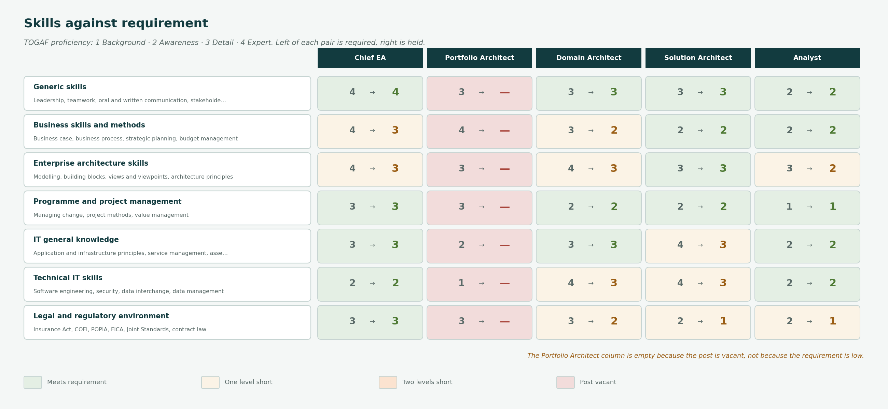
Figure 3 — Required against held proficiency, by skill category and role.
Skill category | Detail | Chief EA | Portfolio Architect | Domain Architect | Solution Architect | Analyst
Generic skills | Leadership, teamwork, oral and written communication, stakeholder management | 4 → 4 | 3 → — | 3 → 3 | 3 → 3 | 2 → 2
Business skills and methods | Business case, business process, strategic planning, budget management | 4 → 3 | 4 → — | 3 → 2 | 2 → 2 | 2 → 2
Enterprise architecture skills | Modelling, building blocks, views and viewpoints, architecture principles | 4 → 3 | 3 → — | 4 → 3 | 3 → 3 | 3 → 2
Programme and project management | Managing change, project methods, value management | 3 → 3 | 3 → — | 2 → 2 | 2 → 2 | 1 → 1
IT general knowledge | Application and infrastructure principles, service management, asset management | 3 → 3 | 2 → — | 3 → 3 | 4 → 3 | 2 → 2
Technical IT skills | Software engineering, security, data interchange, data management | 2 → 2 | 1 → — | 4 → 3 | 4 → 3 | 2 → 2
Legal and regulatory environment | Insurance Act, COFI, POPIA, FICA, Joint Standards, contract law | 3 → 3 | 3 → — | 3 → 2 | 2 → 1 | 2 → 1

The Portfolio Architect gap is total, not partial
Every required proficiency for the role reads zero because the post is vacant. Model A currently runs on the Chief Enterprise Architect's residual time, which is why the roadmap has not yet reached a planning cycle.
Regulatory literacy is thin below Domain Architect level
Solution Architects and Analysts sit at 1 against a required 2. For an insurer where COFI, POPIA and the Joint Standards shape most material designs, that pushes regulatory judgement upward and slows review.
Business skills are the weakest category overall
Three of the five roles fall short. The consequence shows in Model A: capability analysis that cannot be argued in commercial terms does not survive a conversation with a Managing Director.
Technical depth is adequate where it matters
Domain and Solution Architects meet or nearly meet requirement on technical IT skills. The capability's problem is not that it cannot read a design.

7. Maturity, gaps and resolution
Assessed using the US Department of Commerce ACMM. Weighted mean 1.97, placing the capability at Level 2. Each element below states the current position, the target, and what closes the gap.
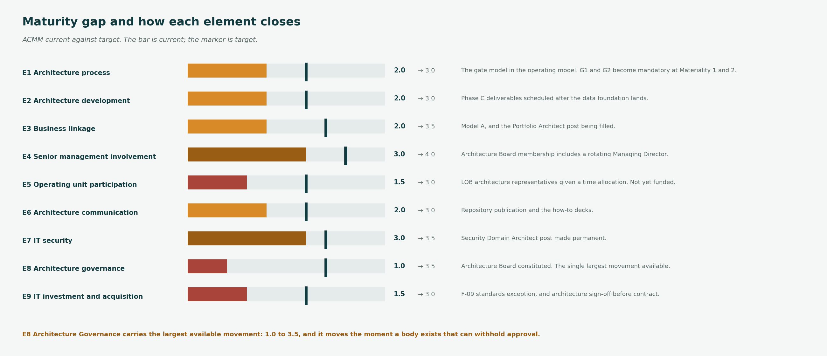
Figure 4 — ACMM current against target, with the resolution for each element.
Element | Current | Target | Where it stands | What closes it
E1 Architecture process | 2.0 | 3.0 | Method tailored but not consistently followed. | The gate model in the operating model. G1 and G2 become mandatory at Materiality 1 and 2.
E2 Architecture development | 2.0 | 3.0 | Domain architectures partial; data and application incomplete. | Phase C deliverables scheduled after the data foundation lands.
E3 Business linkage | 2.0 | 3.5 | Capability map exists; linkage to investment is new. | Model A, and the Portfolio Architect post being filled.
E4 Senior management involvement | 3.0 | 4.0 | Sponsorship exists; attendance is inconsistent. | Architecture Board membership includes a rotating Managing Director.
E5 Operating unit participation | 1.5 | 3.0 | Participation is by invitation, not by structure. | LOB architecture representatives given a time allocation. Not yet funded.
E6 Architecture communication | 2.0 | 3.0 | Content exists; publication does not. | Repository publication and the how-to decks.
E7 IT security | 3.0 | 3.5 | Strongest element. Security principles now elaborated. | Security Domain Architect post made permanent.
E8 Architecture governance | 1.0 | 3.5 | No forum could withhold approval before 2027. | Architecture Board constituted. The single largest movement available.
E9 IT investment and acquisition | 1.5 | 3.0 | Architecture is consulted late in procurement. | F-09 standards exception, and architecture sign-off before contract.

8. Constraints
What the capability cannot change, and how the operating model accommodates each.

Constraint | What it is | How it is accommodated
Headcount against mandate | Fourteen positions, two vacant and one interim, against an establishment of 4,805 and five lines of business. | Materiality triage. Architecture does not review everything, and the triage is published so teams can predict what happens to them.
No budget increase before FY2028 | The Board approved [Organisation] 2030 without an incremental technology budget. | Change funded from run-cost reduction under COA-10. The capability's own growth competes with delivery, and loses.
No federated architecture capacity | LOB architecture representatives have no time allocation and no formal accountability. | The largest single constraint on scaling. Recorded as a gap rather than solved.
Architecture maturity at 2.0 | ACMM weighted mean 1.97. Governance scored 1.0 before the Architecture Board was constituted. | The operating model and the governance framework are the resolution. Both are draft.
Two failed core replacements | 2016 and 2021. Change appetite is bounded by that history. | Increments are sized to what the organisation will accept, not to what would be efficient.
Subsidiaries outside governance | Namibia and Botswana are federated with no standards obligation. | Accepted for now. Revisited if either subsidiary materially integrates with group platforms.

9. Sizing and budget

9.1 Sizing
Measure | Value | Ratio | Reading
Against Group Technology | 14 of 520 | 2.7% | Within the 2–4% band typical for an architecture function inside an IT organisation.
Against the enterprise | 14 of 4,805 | 0.29% | Thin, but the mandate is technology architecture rather than every business process.
Architects per line of business | 0.6 | — | Below one. No line of business has a dedicated architect, which is why Model B triages.
Solution Architects per active initiative | 3 of 11 material initiatives | 27% | The binding constraint on Model B. Eight material initiatives have no assigned Solution Architect.

Undersized against mandate, not against peer group
The capability is not obviously undersized against its technology peer group. It is undersized against its mandate, and the difference matters: adding people to the central team is the expensive answer, and building federated capacity in the lines of business is the one the operating model actually depends on.

9.2 Budget
Line | Amount | Note
Establishment | 14 positions | 12 filled, 1 interim, 1 vacant
Direct cost | R28.4m per annum | Salaries, benefits and employer contributions at full establishment
Tooling and repository | R1.9m per annum | Repository, modelling and collaboration
Capability establishment | R6.4m one-off | COA-01: constituting the Board, the forms and the registers
Training and certification | R0.8m per annum | TOGAF, security and domain certification
Total | R31.1m recurring, R6.4m one-off | 0.9% of technology spend

10. Governance and support strategy
How the capability is sponsored, funded, escalated through and assured.

Aspect | Arrangement | Note
Sponsorship | Chief Information Officer, with Group Exco endorsement | The capability reports through Technology, which is normal at this maturity and a constraint at the next. Business-architecture credibility depends on not being seen as an IT function.
Authority | Architecture Board, chaired by the Chief Enterprise Architect | The Board can withhold approval. Without that, the capability is advisory, which is what the maturity assessment scored at 1.0.
Funding route | Group Technology operating budget, with programme-funded Solution Architects | Solution Architects assigned to Wave 1 and Wave 2 work packages are charged to those work packages, not to the capability.
Escalation | Architecture Board → Group Executive Committee, with the Risk Committee in parallel | Set out in the operating model. Silence escalates automatically.
Assurance | Internal Audit, reporting to the Audit Committee | Architecture governance is auditable. The capability does not assure itself.
Retention risk | Two vacancies, one interim, and a market that pays more for these skills | The largest operational risk to the capability. Named here rather than left to the HR risk register.

The reporting line is normal now and a constraint later
The capability reports through Group Technology, which is usual at maturity 2 and appropriate while the work is predominantly technology architecture. As Model A matures and the capability argues about business capability investment with Managing Directors, reporting through Technology will begin to cost it credibility. Worth revisiting at the FY2029 review rather than now.

11. Document control
Amendment is by replacement. A change to this model is a change request against it, assessed by the Architecture Board, with the previous version retained.

Version | Date | Author | Change
0.1 | March 2027 | Chief Enterprise Architect | Initial draft. Fourteen positions across three layers, four scope categories, seven skill categories assessed across five roles, nine ACMM elements with resolutions, six constraints and the support strategy.

Related documents
- EA Operating Model — how the capability works: two models, gates, forms and escalation
- Architecture Maturity Assessment — the ACMM assessment this section draws on
- Architecture Principles and Security Architecture Principles — what the capability enforces
- Organisation Chart — the enterprise reporting structure this function sits within
- Architecture Repository — holds the deliverable register and the capability's own record

